Shimbo Academy – Network Implementation
(After Action Report)
Patrick O. Selvy
Western Governors University

Table of Contents
Summary 3
Review of Other Work 5
Review of Work 1 5
Review of Work 2 5
Review of Work 3 6
Changes to the Project Environment 7
Methodology 8
Project Goals and Objectives 10
Project Timeline 12
Unanticipated Scope Creep 13
Conclusion 14
References 17
Appendix A 18
Shimbo Network Physical/Conceptional Layout 18
Appendix B 19
Network Logical Diagram 19
Appendix C 20
Throughput and Bandwidth Test 20

Summary
As Zambia transitions from an agriculture-based economy to a technology-driven one, the demand for locally trained technologists has increased. In response to this shift, Shimbo Academy is adapting its curriculum to align with the changing job market by introducing technology-focused classes. Additionally, the Academy plans to integrate technology into classrooms to enhance ongoing education for students and teachers.
To realign the curriculum, Shimbo Academy needed to establish a new network that had not existed before. This network is required to connect to the Internet, support 150 end-user devices, ensure security, segment traffic, and maintain reliable connectivity.
POS-Networking was awarded the contract to design, implement, and support the network according to the Academy's specifications. The solution utilized Starlink as the Internet Service Provider (ISP) and Omada-based Software Defined Networking (SDN) technology for routing and switching. The network was segmented into five VLANs to enhance security and efficiency, ensuring smooth traffic flow.
During the project, POS-Networking encountered several unforeseen challenges. The first hurdle was a delivery delay involving the Omada ER7412-M2 Gateway and the Omada EAP211 Bridge, which were initially reported as available but were back-ordered. Additionally, there was a delay at Zambia Customs due to a paperwork error, as the required import tax document was not attached. We had to request import tax documentation from the vendor to prove that the necessary duties were paid. As a result, the installation of network equipment and cabling was delayed by about one month.
Another issue we faced was the customer's request for POS-Networking to maintain the network after installation. We addressed this ongoing maintenance concern by implementing Omada SDN technology, which allows us to monitor, update, and maintain the network remotely. This technology enabled us to offer maintenance at a lower cost compared to having a technician on-site. Additionally, it allowed us to utilize real-time data while teaching networking courses to students.
The project concluded on August 22, 2024, after a week-long evaluation to ensure the network met our standards of an average upload speed of 100 Mbps and a download speed of 25 Mbps across the local area network (LAN) and through the ISP provider, with bandwidth utilization remaining below 80% of the 1 Gbps LAN capacity.
Shimbo Academy accepted the project on August 24, 2024, expressing satisfaction with our work. They recognized that the project fulfilled their initial goals of introducing external learning resources into classrooms, offering technology classes to students, and providing ongoing education for teachers. The Academy also saw the potential to expand its offerings to deliver these courses to more students while increasing its financial revenue.

Review of Other Work

Review of Work 1
During the network implementation, we encountered a performance issue that negatively impacted the network's speed. Reviewing the logs, we discovered that our traffic was subjected to double NAT: first by the Starlink router and then again by our Omada Gateway. (Starlink, n.d., para. 1).
Starlink recommends placing the Starlink router into "Bypass" mode to resolve this issue. Activating the "Bypass" mode allowed the Omada router to function as the primary router, with the Starlink router serving solely as a WAN connection. This configuration streamlined traffic flow and eliminates the complications caused by double NAT. (Starlink, n.d., para. 1).

Review of Work 2
The Omada Software Defined Network (SDN) Cloud Controller's "Zero Touch" functionality simplifies the setup of network components and reduces the chance of configuration errors (TP-Link Corporation Limited, 2022). This controller automatically assigns devices to the correct VLANs and configures all necessary settings, such as SID, VLAN, routes, and port security.

This functionality allowed us to save valuable person-hours in device configuration. The time saved was redirected to the critical CAT-5e installation, which was at risk of being delayed.

Review of Work 3
Before my initial discussions with Shimbo Academy, I recalled Kishor Singh's article, "Harnessing Digital Technologies for Education in Developing Countries: Need for a Judicious Approach," which highlights important considerations for technologists looking to support underprivileged regions.
One of the key points Singh raises is the necessity for caution when expanding technology in education. Although developing countries may view the internet as a quick route to progress, there are often overlooked trade-offs—such as the potential for increased isolation, a phenomenon that has been commonly observed in developed nations. Moreover, the cultural shifts induced by technology can be significant, akin to those experienced in the United States between Generation X and Millennials (Singh, 2023, sect. "Need for a Cautious and Critical Approach").
Another concern highlighted by Singh is the rapid privatization of education as it shifts from traditional classrooms to digital platforms. In some developing countries, policymakers face pressure from large corporations to continue this trend, which further exacerbates the educational gap between developed and developing nations (Singh, 2023, sect. "Safeguarding Education from Forces of Privatization, Fortified by Digitalization in Education" & "Overcoming the 'Digital Divide'").
As a technologist who has engaged with Singh's insights, I found them valuable for discussing the potential pitfalls and limitations that the network project could impose on students and teachers. His observations helped me recommend that the administration implement stricter content controls on social media and advocate with the government for free education for all.

Changes to the Project Environment
At the beginning of the project, there was no network infrastructure, meaning staff managed student records using paper files. Teachers conducted their lessons on chalkboards and distributed handouts to students. The school relied on the "Sneaker Net" method to transfer documents between the few standalone systems that were operational. This setup did not align with the client's goal of preparing students for a technology-driven future.
Deploying the network on campus dramatically transformed the environment. The administration is now able to store student files on a server, improving efficiency and accessibility. Teachers can incorporate a wider variety of learning resources directly into the classroom. Additionally, the school has introduced technology courses such as CompTIA A+, CompTIA Net+, CompTIA Sec+, and Cisco CCNA, providing students with valuable skills for the future.
One challenge that arose during the project was the need for stricter content monitoring on the firewall. The initial configuration allowed overly broad access, leading to scope deviation in classroom instruction. To resolve this issue, we collaborated with the school during the initial phase to develop a whitelist for the “SC-Teacher” VLAN and implement content restrictions.
Overall, the completed project met Shimbo Academy's expectations. The network brought significant positive changes to the school environment, setting students on a path toward a technology-focused future.

Methodology
For the Shimbo Academy Network Project, I utilized the Waterfall methodology, which consisted of four distinct phases: Planning, Design, Implementation, and Testing. This method was selected because each phase depended heavily on the completion and success of the previous one, making a linear project flow ideal.
During the Planning phase, we held multiple meetings with school administrators to refine the scope of the project. The initial meeting focused on reviewing the “Request for Bid,” which outlined the need to design a network from the ground up to support at least 150 users with internet access—an essential component of the school’s shift toward technology-based education. This meeting also served as an introduction to our team, during which we shared a conceptual network design and a budget proposal to align with the school's goals.
A key point of discussion was that POS-Networking would be responsible for the physical buildout of the network infrastructure and would also maintain the network and act as adjunct instructors for the school's networking courses. While POS-Networking initially viewed this as scope creep, we proposed a solution to split the work into two distinct projects—“Building” and “Maintaining” the network. Both parties agreed to proceed on these terms, and a follow-up meeting was scheduled to finalize the design.
At the second project meeting, we presented the proposed timeline for review and client approval. We also walked through the Network Physical Diagram (Appendix A) and the Network Logical Diagram (Appendix B). During this session, we were informed that the school had recently acquired two servers that needed to be integrated into the design. Our lead architect made the necessary adjustments on the spot to avoid delays, and the final design was approved. At the conclusion of the meeting, all contracts were signed, allowing us to move forward to the next project phase.

Initial Project Timeline with Milestones

Milestone | Duration  (hours or days) | Projected Start Date | Anticipated End Date
Planning | 3 Weeks | 28 Jun 2024 | 16 May 2024
Design | 2 Weeks | 19 May 2024 | 30 May 2024
Procurement | 5 Weeks | 2 June 2024 | 4 July 2024
Configurations | 2 Weeks | 7 July 2024 | 18 July 2024
Installation | 3 Weeks | 7 July 2024 | 25 July 2024
Testing | 1 Week | 28 July 2024 | 1 Aug 2024
The Implementation Phase of the project—which encompassed procurement, configuration, and installation—was where we encountered project delays. Initially, we estimated that procuring the STARLINK system, OMADA gateway, switches, wireless bridge, access points, CAT-5e cabling, and uninterruptible power supplies (UPS) would take approximately five weeks from purchase to site delivery. However, due to unforeseen delays in logistics, it ultimately took eight weeks for all components to arrive on-site for configuration.
The Configuration sub-phase was completed one week ahead of schedule. This efficiency was largely due to the implementation of the OMADA Software Defined Networking (SDN) solution, which allowed the network to be dynamically configured as devices came online.
During the Installation sub-phase, POS-Networking encountered a challenge running CAT-5e cable through the facility. The building’s cinder block construction made it difficult to secure cable mounts properly. Resolving this issue added an extra week to the schedule. Fortunately, we mitigated a potential two-week delay by reallocating manpower—reassigning engineers to assist technicians and accelerate installation.
During network stress testing, engineers observed that bandwidth loss did not exceed 5% (Appendix C). Efficient bandwidth utilization was achieved by configuring the OMADA gateway to restrict content that typically causes network congestion, such as streaming services and social media platforms.

Project Goals and Objectives
POS-Networking successfully met all goals and objectives originally outlined for the Shimbo Academy. Some deliverables required workarounds and coordination with vendors to resolve, but all were addressed.
Phase | Goal | Supporting Objectives | Deliverables Enabling the Project Objectives
1 | Planning, Design, and Procurement | Planning | Stakeholder Meeting
 |  |  | Project Meeting
 |  |  | Sign contracts
 |  | Design | Design logical network
 |  |  | Design physical network
 |  | Procurement | Procure WAN ISP
 |  |  | Procure all wire, tools, network equipment, and UPS for the project
2 | Configure and Install | Configuration | Configure Network device
 |  | Installation | Physical cabling
 |  |  | Network Equipment
3 | Testing | Testing | Network

During the procurement phase for the Cat-5e ceiling run, we encountered a delay when attempting to source traditional wire racks. The required cable trays had a 12-week lead time, which was deemed unacceptable for the project timeline. To maintain progress, we locally sourced aluminum rain gutters as an alternative. These effectively supported and elevated the wire runs throughout the building, achieving the same outcome as conventional trays.
The second issue arose during the NAT configuration of the internal ports to the STARLINK IP address. Initially, the network operated as expected, with internal IPs successfully NATed to the external IP. However, during the testing phase, we observed that NAT functionality had ceased. Upon investigation, we determined that STARLINK was assigning IPs via DHCP, resulting in an unexpected IP address change. This raised security concerns, as our team was committed to maintaining a NATed environment. After reviewing STARLINK’s documentation and consulting with OMADA support, we reconfigured the OMADA device’s two WAN ports to enable NAT with DHCP-assigned IPs.
Despite these two challenges, POS-Networking successfully delivered all promised outcomes to Shimbo Academy. As with any IT project, we anticipated unforeseen issues and had built adequate buffer time into the project schedule to accommodate them.

Project Timeline
POS-Networking had to extend the Final Timeline by three weeks beyond the Initial Timeline due to delays during the procurement phase. These delays were caused by the manufacturer's shipping timeline to Zambia and processing by Zambian customs. To avoid further setbacks, the “Configurations” phase was shortened by one week through the use of SDN technology. Additionally, the “Installation” phase was completed by dedicating extra hours and having the full team work intensively during this period.
Initial Timeline
Milestone | Duration  (hours or days) | Projected Start Date | Anticipated End Date
Planning | 3 Weeks | 28 June 2024 | 16 May 2024
Design | 2 Weeks | 19 May 2024 | 30 May 2025
Procurement | 5 Weeks | 2 June 2024 | 4 July 2024
Configurations | 2 Weeks | 7 July 2024 | 18 July 2024
Installation | 3 Weeks | 7 July 2024 | 25 July 2024
Testing | 1 Week | 28 July 2024 | 1 Aug 2024
Final Timeline
Milestone | Duration  (hours or days) | Projected Start Date | Anticipated End Date
Planning | 3 Weeks | 28 June 2024 | 16 May 2024
Design | 2 Weeks | 19 May 2024 | 30 May 2024
Procurement | 5 Weeks | 2 June 2024 | 1 Aug 2024
Configurations | 2 Weeks | 4 Aug 2024 | 8 Aug 2024
Installation | 3 Weeks | 4 July 2024 | 15 Aug 2024
Testing | 1 Week | 18 Aug 2024 | 22 Aug 2024
Completion | 1 Day | 22 Aug 2024

We completed the project on August 22, 2024, and started the network's production phase on August 24, 2025. Shimbo Academy accepted the project on August 23, 2024.

Unanticipated Scope Creep
The initial Request for Bid from Shimbo Academy focused on designing and installing a network to support their goal of integrating technology into the classroom. During the initial meeting with the school's leadership, the leadership proposed that taking on the contract would also require POS-Networking to maintain the network.
The first scope creep occurred when we adjusted the network design to accommodate long-term maintenance. We added the Omada Software Defined Networking (SDN) cloud controller to the design and implementation to address this additional requirement. The Omada SDN allowed us to perform remote monitoring, maintenance, and security functions. However, including this SDN package increased the initial bid cost, as we needed to factor in the price of the subscription and the personnel required for network maintenance.
The second alteration to the original plan happened when the Academy acquired two servers designated for teacher and staff use, which would not have access to the Internet. The new requirement necessitated the creation of a subnet to accommodate the new infrastructure. Consequently, we modified our initial design by adding the 192.8.25.0/31 subnet to connect the two servers to the LAN. We allowed access only to the SC-Teacher (Teacher) and SC-Admin (Administration) VLANs. At the same time, all other routing policies explicitly denied routing traffic to the 192.8.25.0/31 subnet.
The scope creep resulted from the Academy's lack of communication regarding their complete requirements in the original Request for Bid documents. Despite these changes, POS-Network accepted the requests because they aligned with the Academy's valuable mission. The adjustments were managed effectively, ensuring the project's success.

Conclusion
At the end of the testing period, we evaluated the project's success by confirming that each device could access internet resources such as YouTube and the Zambia Ministry of Education's website from both the wireless local area network (WLAN) and the ports on the local area network (LAN). Additionally, we were able to navigate from a test laptop on the SC-Teacher VLAN to the storage server, demonstrating that we had established internal connectivity on the LAN.
The Wide Area Network (WAN) connection maintained an average upload speed of 169 Mbps and a download speed of 57 Mbps (see Appendix C). This was measured over seven days across both the LAN and WAN. The connection speed was significantly higher than our initial estimates of 100 Mbps for uploads and 25 Mbps for downloads. We believe this discrepancy was due to our initial estimates being based on Starlink's personal plan rather than their business plan, which we ultimately selected.
During testing, we deployed five teams simultaneously throughout the school to access the internet and LAN resources in order to measure bandwidth utilization. We observed that bandwidth utilization never exceeded 30% (see Appendix C), which met our standard of keeping utilization below 80%. However, this test may be a false positive indicator, as POS-Networking could not fully simulate the entire network load. If bandwidth issues arise as production continues, we can address them by managing traffic more effectively and adding a Starlink system to separate the VLANs between the two Starlink systems.
The immediate impact of our project became apparent when teachers began to incorporate additional resources, such as YouTube, Google Search, and CB-Nugget courses, into their classrooms. These internet resources enabled students to visualize the concepts they were learning rather than just imagining them. Furthermore, staff and teachers could efficiently communicate student grades and provide specialized assistance to those requiring extra support using the two servers.
However, not all immediate outcomes were entirely positive. Some students attempted to misuse the network, which can be common behavior for both children and adults. In response, POS-Networking collaborated with school administrators to tighten the whitelist, striking a balance between accessibility and security.
Overall, the project serves as a model for other stakeholders in Zambia, including the Ministry of Education, demonstrating how schools can lead technological advancements. For many small, rural schools in Zambia, which often lack direct access to circuits, a low-earth orbit (LEO) connection combined with a small network can provide students with opportunities to embrace the future and reach their full potential.

References
Starlink. (n.d.). How do I set up my Starlink router with a third party router or mesh system? Starlink. Retrieved June 20, 2025, from https://www.starlink.com/support/article/1192f3ef-2a17-31d9-261a-a59d215629f4

Starlink. (n.d.). How do I set up my Starlink router with a third party router or mesh system? Starlink. Retrieved June 20, 2025, from https://www.starlink.com/support/article/a0fe8d51-32f7-d2b9-d74a-801e31ad9f6a

TP-Link Corporation Limited. 1​ (2022). 2​ Omada: The smarter cloud solution for business networking. 3​ Retrieved from https://www.tp-link.com/omada-sdn

Singh, K. (2023, October 27). ​ Harnessing digital technologies for education in developing countries: Need for a judicious approach. ​ South Centre. Retrieved from https://www.southcentre.int

Appendix A

Shimbo Network Physical/Conceptional Layout
The physical/conceptual layout demonstrates to stakeholders and the team in which building each piece of equipment will be located. The diagram also serves as a quasi-part list for the procurement. 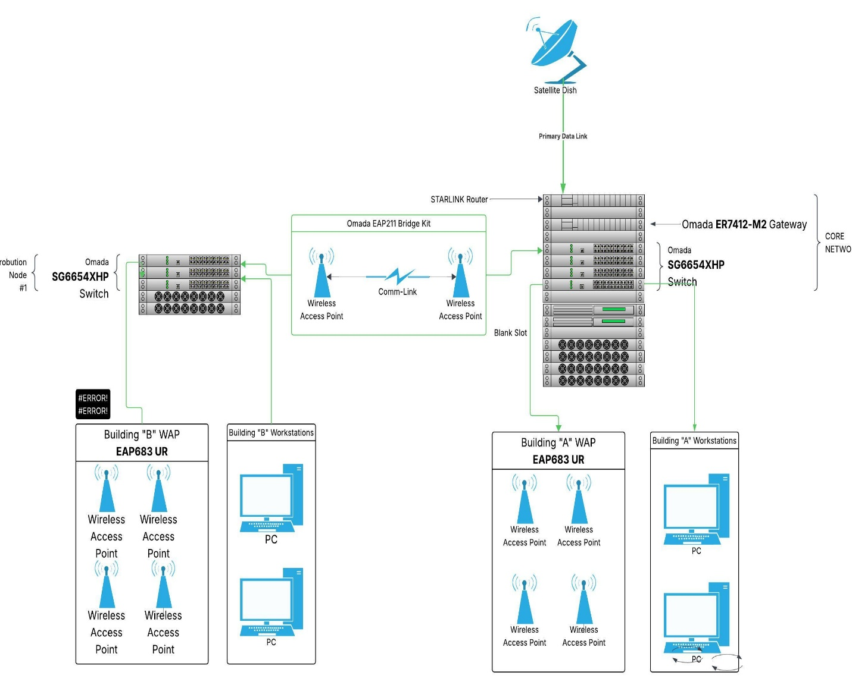

Appendix B

Network Logical Diagram
The logical network diagram acts as a guide for configuring the network according to the stakeholders' requirements. It illustrates the logical routing, including virtual Local Area Networks (VLANs), subnets, Network Address Translations (NAT), Software Defined Network (SDN) architecture, and the connection to the Internet.
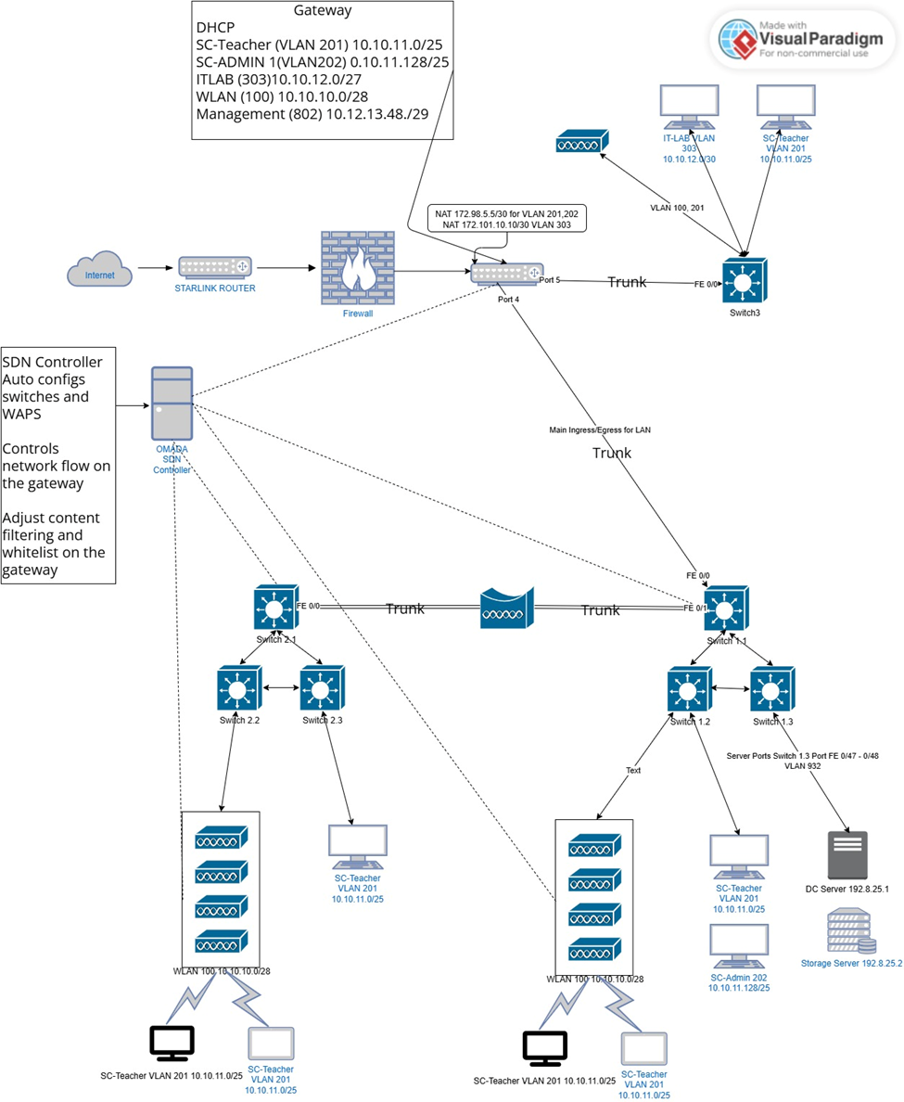

Appendix C

Throughput and Bandwidth Test
The throughput and bandwidth utilization reports indicate that the testing phase has been successfully completed. They also demonstrate that we have met our test metrics of 100 Mbps for uploads and 25 Mbps for downloads, all while using less than 80% of the available bandwidth.
Throughput Test
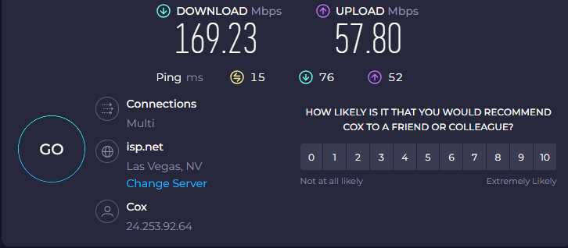
Bandwidth Test
